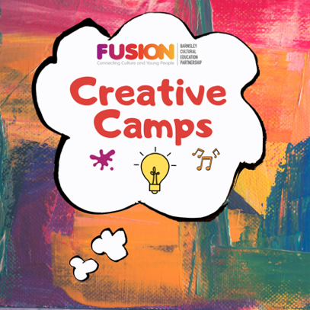

Fusion Creative Camps Expression of Interest Form

Fusion, Barnsley’s Cultural Education Partnership, is seeking to contract up to 10 artists/creative practitioners/arts and cultural organisations on a freelance basis to deliver one of four weekly-sessions (three in August and one in October 2020).

The activities will offer families a chance to experience a wide range of arts and cultural approaches with sessions based around an activity broadly themed to support wellbeing (‘This is Me’, ‘Extreme Explorers’, ‘Outdoor Adventuring’*). Artists will need to use their artform to interpret the theme. A key aim of the project is to facilitate new relationships so artists will be put into a team of 3 to deliver their activity week and will be allocated a theme.

*Please note an additional theme will be added for Activity Week 4 in October or one of the August sessions may be repeated.

The first activity week will be 3rd August. Please note due to the incredibly tight timeframe we have artists lined up to deliver the first week.

Please submit this short application form by 12 noon on Friday 24th July. Your response should be no more than 3 sides of A4 and emailed to sara@maireducation.com. If you have any queries please contact Sara Mair, Fusion Co-ordinator on 07944 911093 or sara@maireducation.com.

Name of artist/creative practitioner/arts and cultural organisation |  | Main contact name
Email |  | Phone
Website/social media link
Have you used Zoom before? | Yes No | Do you have access to bandwidth that can support Zoom? | Yes No

Availability (please indicate your availability in the table below)

Activity Week |  | Availability
Activity Week 1 | 3rd August to 7th August | Already allocated
Activity Week 2 | 10th August to 14th August
Activity Week 3 | 17th August to 21st August
Activity Week 4 | 20th October to 26th October

What artform/s do you specialise in?
Please tell us about your experience developing and delivering creative workshops to children at primary age (Reception, KS1 or KS2) and their families (this could be in person or online).
Please give an outline of any ideas you might want to consider developing for Creative Camps?
Please tell us about your experience of collaborating on a creative project.
Why do you want to be involved in this project?

